Last Updated 3/28/2018

**iCenter Server Installer Overview**

The server installer is windows deployment project used for setting up and providing an initial working configuration for the background system, the desktop click once applications, and the system manager. The installer includes the desktop applications (in a zip) as well as Microsoft’s utilities for creating a click once application which check for automated updates on launch. The update URL in the click once manifest file is generated by Microsoft utilities and the end of the installation process.

**Installer Download**

The server installer package is generated by the build server and is available as an *artifact*. This can be found at [*http://lumbuildw7-vmb:8080*](http://lumbuildw7-vmb:8080/project.html?projectId=LtgGorbaIMotionTftDisplay&tab=projectOverview)

Select “*i*[*Motion, Server and WFP Desktops CD - develop branch*](http://lumbuildw7-vmb:8080/viewType.html?buildTypeId=LtgGorbaIMotionTftDisplay_IMotionTftDisplayBuild)*”*

*Select Artifacts.*

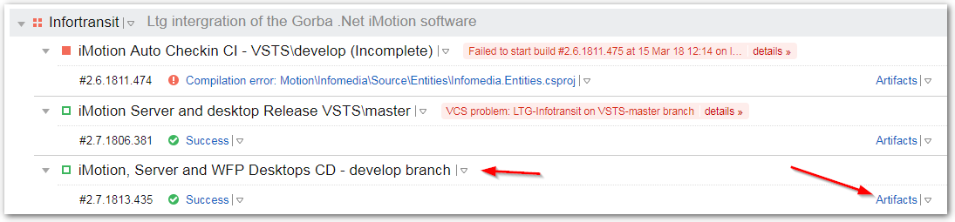

**Select the ServerInstallerx.x.xxx.xxx file.** This contains the setup app.

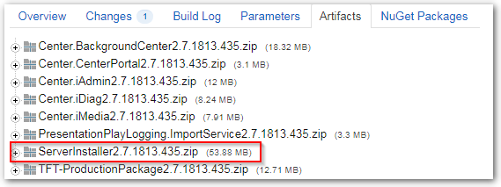

**PreInstaller steps for prior install version**

Before extracting and executing the installer “msi”. Backup your old server installer files found in *“C:\Apps”* or the path was specified during the prior install. Go into “Programs and Features” and uninstall “INFOtransit Server and Desktop”.  
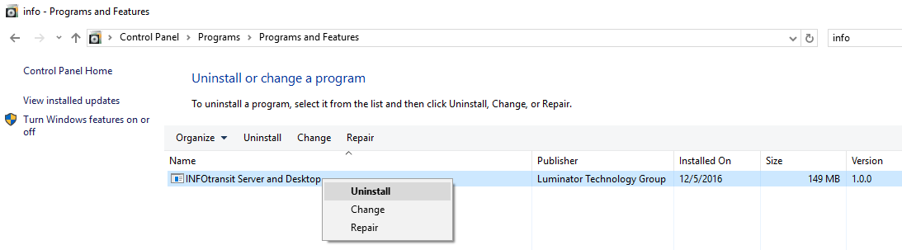

**Executing the installer**

Extract the server installer artifact files and run install on “ServerInstaller.msi” under whatever windows service account login you need to.

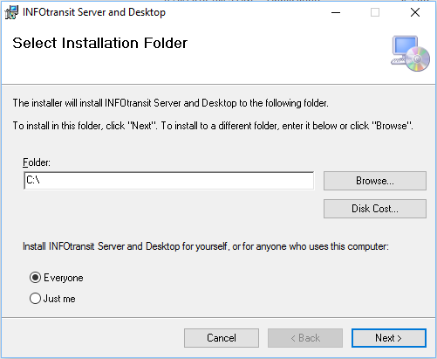

The path *C:* will is fine and will create a *C:\Apps* directory for the server install files.

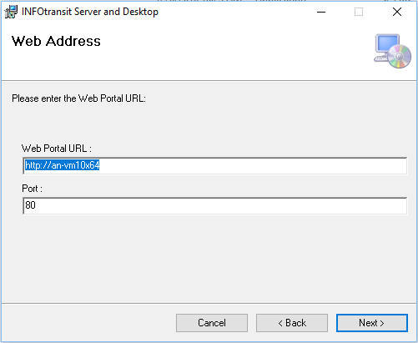

Fill in the “Web Portal URL”, this is the URL where the portal website is hosted and is also where the click-once application checks for updates. The port number is the port for the website, 80 is the default web / http port.

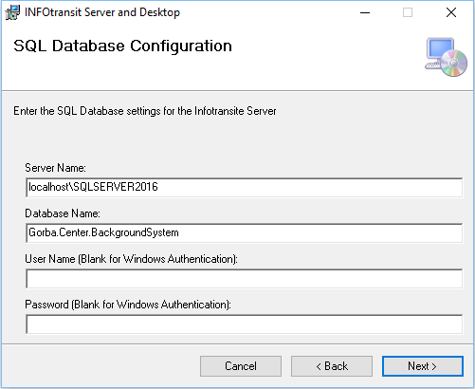

“Server Name” is the SQL Server Instance name. The database name is defaulted to *Gorba.Center.BackgroundSystem*. If you leave the SQL username and password blank it will default to windows account login.

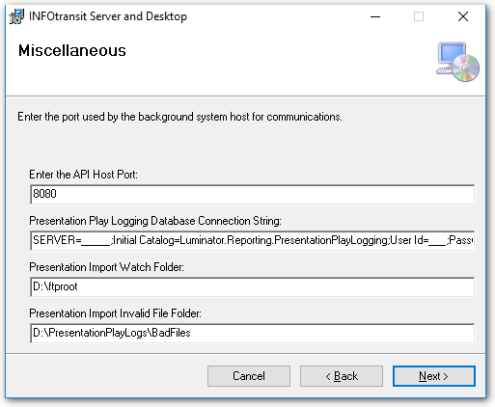

* API Host Port – communication port used by Portal, default is 8080.
* Connection string – likely the same used by the previous SQL connection string.
* Watch Folder – the location on the FTP server where presentation log files are uploaded, from the units. **This will need to be a UNC path if the FTP server is running on a separate server**.
* Invalid File Folder – Where invalid CSV files are placed, as they are unable to be imported.

Review, confirm your settings and click next to begin your install. During this process UAC will prompt you for permission to execute the install.

**Review the Install Folders**

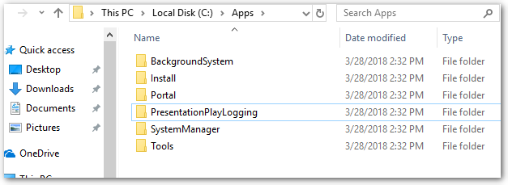

* **BackgroundSystem** – This is primary server process
* **Install** – This contains the packaged desktop applications before it was converted to a click-once application by the installer as well as the .NET libraries used by the installer to zip/unzip files.
* **Portal** – This is the website that host the desktop click-once applications (admin, diag, media).
* **SystemManager** – Process that starts / restarts other processes
* **PresentationPlayLogging** – The presentation play log import process, used to import the CSV files into the database.
* **Tools** – This contains Microsoft tools to deploy a desktop application as a click-once application. The click-once application has an update URL. These tools generate the manifest files required with the update URL so that click-once download and update function.

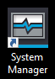

The installer places this icon on your desktop, upon executing it you will see 4 console windows. Review the screens and troubleshoot it should any errors occur. Browse to the portal website and login, install the click-once apps and test them. This completes this quick install guide.

